**RESUME**

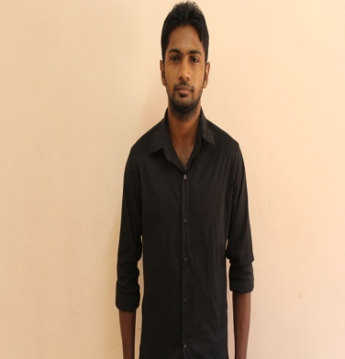__________________________________________________________________________________

**George s/o Savriappan**

Email : [georgejo1992@gmail.com](mailto:georgejo1992@gmail.com)

Mobile : 016-9598411

*Career Objective*

To work with a progressive organization and seek a challenging career which nourishes my passion to excel by grabbing the opportunities to learn new technologies, accept newer and higher responsibilities and thereby enhance and sharpen my creative and analytical skills for the benefit of the organization and even myself.

*Personal Details*

Name : George s/o Savriappan

Date of Birth : 19 June 1992

Address : No. 111, Ladang Renjok, 28620 Karak, Pahang Darul Makmur.

Contact No. : 016-9598411

Email ID : [georgejo1992@gmail.com](mailto:georgejo1992@gmail.com)

Language Known : English, Tamil, Malay

*Education and Qualifications*

Year 2010 – 2013 Politeknik Ibrahim Sultan, Johor Bahru

Diploma in Hotel and Catering Management

* 3.23 CGPA
* Participated in The Longest Swiss Roll in Malaysia 2012 (Successful broke the Malaysian Book of Records)
* Participated in Junior Master Chef Programme around Johor in 2013

Year 2005 – 2009 Sekolah Menengah Kebangsaan Telemong, 28620 Karak, Pahang

Sijil Pelajaran Malaysia (2A 6B 1C)

*Work Experience*

February 2014 –

May 2014 Nandos Chickenland, Sunway Giza, Damansara

* Manage people and product
* Handling document
* Communicate with customer

June 2012 –

December 2012 Practical Semester – Trainee

Mahkota Hotel Melaka

* Obtained in planning and maintaining the service standards of housekeeping department.
* Managed and supervised a housekeeping inspection
* Handling reception process.
* Maintain guess detail.

June 2010 –

August 2010 Genting Palace Restaurant

* Worked as part time waiter

*Extra – Curriculum*

**Malaysian football league**

* Shazan muda football club
* Malaysian Indian football association (MIFA)
* IPT football league
* Inter college football league

**Marathon MSSM (2009)**

**Hockey**

* District level (MSSM)
* Sukan remaja

*Skills, Strengths and Abilities*

* Excellent in Communication, Public Relation, Guest Services and Management Skills.
* A person who self-motivate, independent, disciplined and matured.
* Able to plan, organizing, and maintaining the service standards of the hotel.
* Passionate in setting high performance standards and meeting objectives.
* Proactive and versatile with good managerial and leadership abilities.
* Able to have interpersonal and communication skills with all level of staff.

*Reference:*

MR. Sarmesh

Manager of Nandos SS2

Nandos Chickenland.

0162183494